# HelpNow medical Center

345 Central Avenue

Wichita, Kansas 67212

# Customer Name

**Street Address**

City, State, 00000

# Prospective Franchisee Open Houses

# Important Data for a Prospective Franchisee

Get to Know Us!

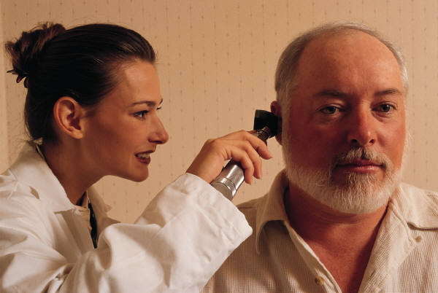

HelpNow Medical Center

* Saturday, May 12th, 9 a.m. to 5 p.m.
* Tuesday, May 15th, 4 p.m. to 8 p.m.
* Saturday, May 19th, 9 a.m. to 5 p.m.

HelpNow Medical Center

# Control Your Own Destiny

## Tired of HMOs?

Join with local doctors to create a HelpNow Medical Center in your town, and practice real, patient-oriented medicine once again. Profit from our 20 years of experience in the medical emergency field, while maintaining control over your business. Let us show you how to make a living without sacrificing patient care. Call now to reserve your place at one of our upcoming Open Houses!

Page 2 For More Information, Call: (316) 555 1354

# Current Assets

# Current Liabilities

HelpNow Medical Center Page 3